**Aim**

**To design and deploy a cloud-based Library Book Reservation System for SIMATS Library using Zoho Creator, thereby demonstrating Software as a Service (SaaS).**

**Procedure**

1. **Login to Zoho Creator**
   * **Open Zoho Creator and sign in with your Zoho account.**
2. **Create a New Application**
   * **Click Create Application → From Scratch.**
   * **Name it: SIMATS Library Book Reservation System.**
3. **Design the Reservation Form**
   * **Create a form titled Library Book Reservation Form.**
   * **Add fields for Student Details, Book Details, and Reservation Details as listed above.**
4. **Create Reports (Views)**
   * **Generate a Book Reservation Report to list all reserved books.**
   * **Apply filters based on Student Name, Book Title, or Status.**
5. **Add Workflow (Optional)**
   * **Send an email/SMS notification to the student after a successful reservation.**
   * **Configure reminders before return due date.**

**Output:**

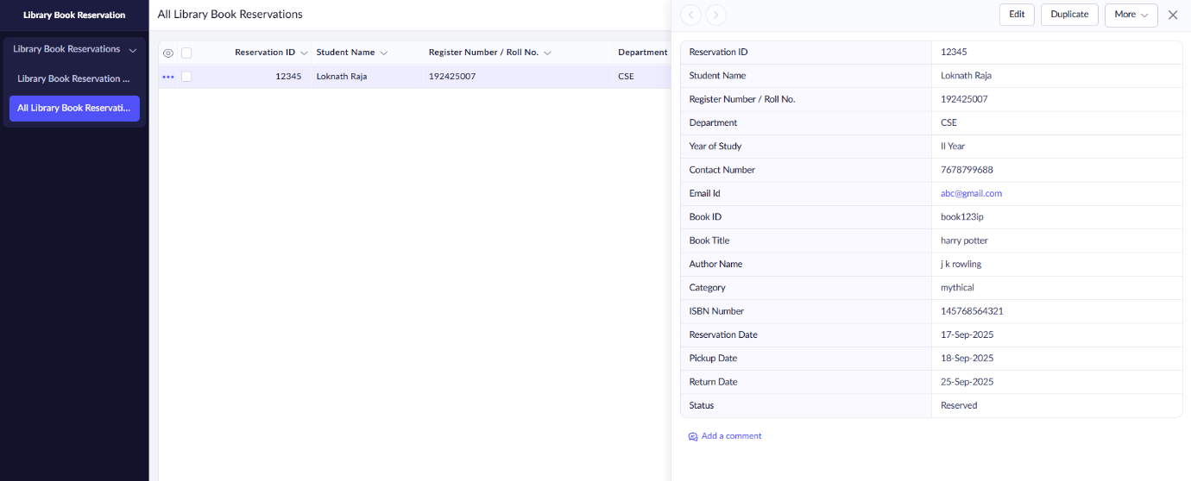

**Result**

* **A Library Book Reservation System for SIMATS Library was successfully created and deployed on Zoho Creator.**
* **Students can reserve books online by filling out their details and selecting book information.**
* **Reports provide quick access to student reservations, book availability, and return status.**
* **Hosted on Zoho’s cloud, the system demonstrates Software as a Service (SaaS) by offering a scalable, user-friendly, and globally accessible library management solution.**